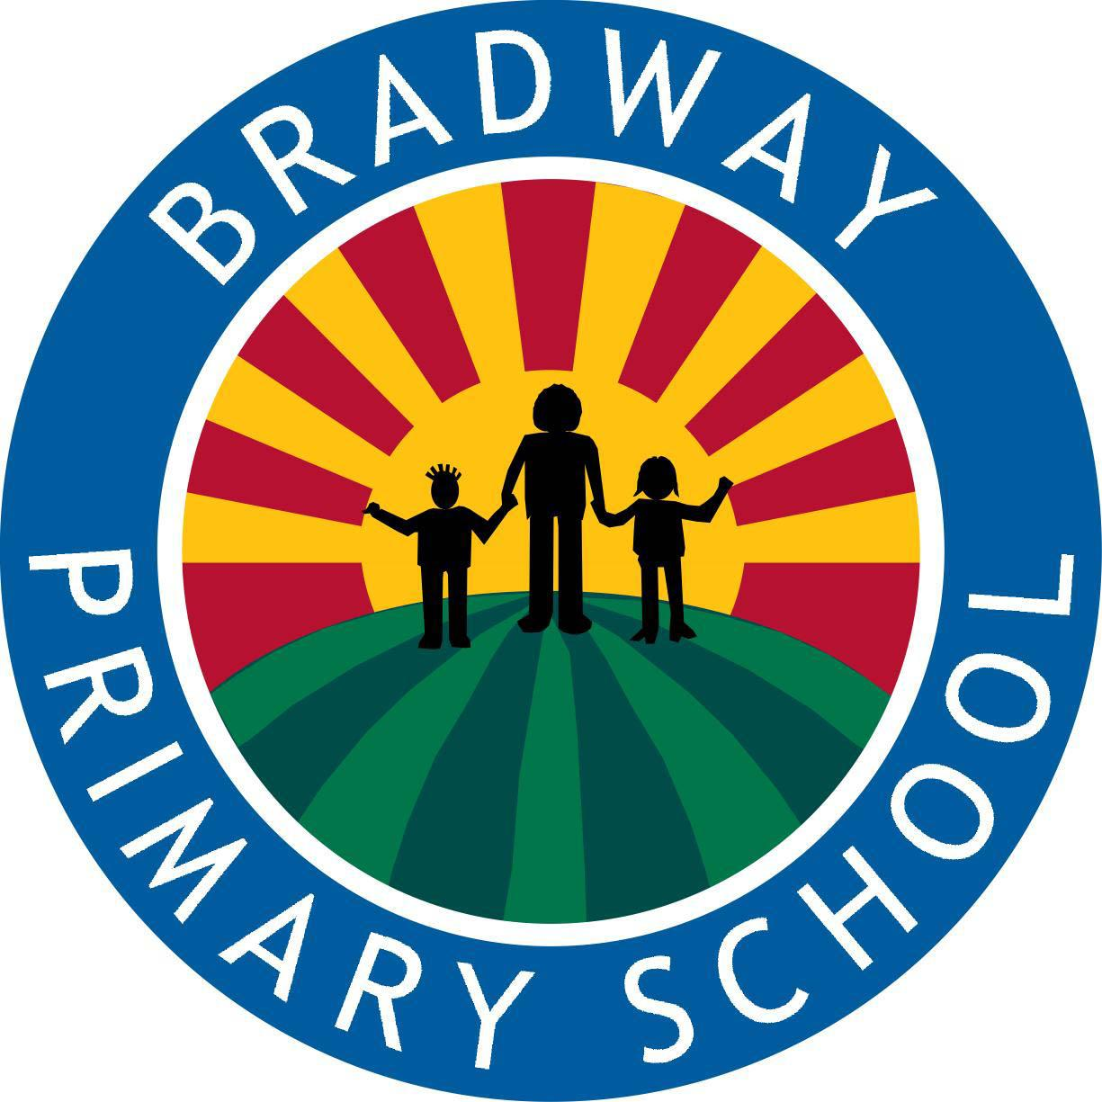 | Privacy notice for parents and carers and their children's data

Contents
1. Introduction 2
2. The personal data we hold 2
3. Why we use this data 2
4. Our lawful basis for using this data 3
5. Collecting this data 4
6. How we store this data 5
7. Who we share data with 5
8. Your rights 6
9. Complaints 8
10. Contact us 8

1. Introduction
Under UK data protection law, individuals have a right to be informed about how our school uses any personal data that we hold about them. We comply with this right by providing ‘privacy notices’ (sometimes called ‘fair processing notices’) to individuals where we are processing their personal data.
This privacy notice explains how we collect, store and use personal data about pupils at our school and their parents/carers.
We, Bradway Primary School, Bradway Drive, Sheffield, S17 4PD, are the ‘data controller’ for the purposes of UK data protection law.
Our data protection officer is EduDataPro (see ‘Contact us’ below).

2. The personal data we hold
Personal data that we may collect, use, store and share (when appropriate) about you and your child or children includes, but is not restricted to:
- Contact details and contact preferences (such as your names, address, email address and telephone numbers),
- Pupil date of birth, identification documents
- Parents/carers email addresses, telephone numbers
- Details of your family circumstances
- Records of your correspondence and contact with us
- Details of any complaints you have made
- Results of internal assessments and externally set tests
- Pupil and curricular records
- Behavioural information (such as exclusions and any relevant alternative provision put in place)
- Attendance information
- Details of any safeguarding information including court orders or professional involvement
- Details of any support received, including care packages, plans and support providers
- Photographs, videos and CCTV images captured in school
- Data about use of the school’s information and communications systems, equipment and facilities (e.g. school computers)

We may also collect, use, store and share (when appropriate) information about you or your child that falls into "special categories" of more sensitive personal data. This includes, but is not restricted to, information about:
- Any medical conditions we need to be aware of, including physical and mental health
- Characteristics, such as ethnicity, languages spoken or special educational needs
We may also hold data about your child that we have received from other organisations, including other schools and local authorities.

3. Why we use this data
We collect and use the data listed above to:
- Support pupil learning
- Monitor and report on pupil attainment and progress
- To contact you about your child and the running of the school
- Provide appropriate pastoral care
- Protect pupil welfare and keep children safe (e.g.food allergies, or emergency contact details)
- Assess the quality of our services
- Administer admissions waiting lists
- Carry out research
- Comply with the law regarding data sharing
- Meet the statutory duties placed upon us for the Department for Education data collections
- Keep you informed about the running of the school (such as emergency closures) and events
- Process payments for school services and clubs
- Make sure our information and communication systems, equipment and facilities (e.g. school computers) are used appropriately, legally and safely
- To ensure network and information security, including preventing unauthorised access to our computer and electronic communications systems and preventing malicious software distribution.
We will only use you and your child’s personal information for the purposes for which we have collected it, unless we reasonably consider that we need to use it for any other reason and that reason is incompatible with the original purpose. If we need to use your or you child’s personal information for an unrelated purpose, we will notify you and explain the legal basis that allows us to do so.
Please note that we may process you or your child’s personal information without your knowledge or consent in compliance with the above rules where this is required or permitted by law
3.1 Use of your personal data for marketing purposes
Where you have given us consent to do so, we may send you marketing information by email or text promoting school events, campaigns, charitable causes or services that may be of interest to you.
You can withdraw consent or ‘opt out’ of receiving these emails and/or texts at any time by contacting us (see ‘Contact us’ below).
3.2 Use of your child’s personal data in automated decision making and profiling
We do not currently process any personal data through automated decision making or profiling. If this changes in the future, we will amend any relevant privacy notices in order to explain the processing to you, including your right to object to it.
3.3 Use of your child’s personal data for filtering and monitoring purposes
While your child is in our school, we may monitor their use of our information and communication systems, equipment and facilities (e.g. school computers). We do this so that we can:
- Comply with health and safety and other legal obligations
- Comply with our policies (e.g. child protection policy, IT acceptable use policy) and our legal obligations
- Keep our network(s) and devices safe from unauthorised access, and prevent malicious software from harming our network(s)
- Protect your child’s welfare

4. Our lawful basis for using this data
Our lawful basis for processing you and your child's personal data for the purposes listed in section 3 above are as follows:
- Legal obligation: the processing is necessary for you to comply with the law (not including contractual obligations). We need to process data to meet our responsibilities as a school under UK law as set out here: https://www.gov.uk/government/collections/statutory-guidance-schools
An example of this is ‘safeguarding children and young people’
- Public task: the processing is necessary for you to perform a task in the public interest or for your official functions, and the task or function has a clear basis in law. Managing a school is considered a ‘task in the public interest’. Further details are available here: https://www.gov.uk/government/collections/statutory-guidance-schools
Less commonly, we may also use personal information about you where:
- We ask for your Consent: the individual has given clear consent for you to process their (or their child's) personal data for a specific purpose. An example of this may be certain uses of photographs of your child.
- We need to protect an individual’s vital interests (i.e. protect your life or someone else’s life), in situations where you’re physically or legally incapable of giving consent
- The data needs to be processed for health or social care purposes, and the processing is done by, or under the direction of, a health or social work professional or by any other person obliged to confidentiality under law.
- The data needs to be shared with another data controller under a ‘recognised legitimate interest’ either to allow them to fulfil their ‘public task’ obligations or using a ‘condition’ such as ‘safeguarding a vulnerable individual’, ‘crime’, ‘emergency’, or ‘national security’. In this instance anyone under 18 is defined as a ‘vulnerable individual’
Where you have provided us with consent to use your data or your child’s data, you may withdraw this consent at any time. We will make this clear when requesting consent, and explain how you would go about withdrawing consent if you wish to do so.
Some of the reasons listed above for collecting and using personal information about you overlap, and there may be several grounds which justify the school’s use of your data.
4.1 Our basis for using special category data
For ‘special category’ data, we only collect and use it when we have both a lawful basis, as set out above, and one of the following conditions for processing as set out in UK data protection law:
- We have obtained your explicit consent to use your child’s personal data in a certain way
- We need to protect an individual’s vital interests (i.e. protect your child’s life or someone else’s life), in situations where you’re physically or legally incapable of giving consent
- We need to process it for the establishment, exercise or defence of legal claims
- We need to use it for reasons of substantial public interest as defined in legislation
- We need to process it for health or social care purposes, and the processing is done by, or under the direction of, a health or social work professional or by any other person obliged to confidentiality under law
- We need to use it for public health reasons, and it’s used by, or under the direction of, a professional obliged to confidentiality under law
- We need to use it for archiving purposes, scientific or historical research purposes, or for statistical purposes, and the use is in the public interest

5. Collecting this data
We will only collect and use your data when the law allows us to (as detailed above in section 4 of this notice).
While the majority of information we collect about you and your child is mandatory, there is some information that can be provided voluntarily.
Whenever we seek to collect information from you, we make it clear whether you must provide this information (and if so, what the possible consequences are of not complying), or whether you have a choice.
Most of the data we hold about your child will come from you, but we may also hold data about your child from:
- Sheffield City Council
- A previous school or trust
- Government departments or agencies
- Health authorities
- Police forces, courts, tribunals
- Use of the school network and equipment via our appropriate filtering and monitoring systems in line with DfE guidance and KCSIE

6. How we store this data
We keep personal information about you and your child while they are attending our school. We may also keep it beyond their attendance at our school if this is necessary to comply with our legal obligations or to meet our regulatory requirements. Our record retention policy sets out how long we keep information about pupils.
If you wish to see a copy of the schools retention policy please ask at the main school office.
We have put in place appropriate security measures to prevent you and your child’s personal information from being accidentally lost, used or accessed in an unauthorised way, altered or disclosed.
We will dispose of you and your child’s personal data securely when we no longer have a legal requirement to retain it.

7. Who we share data with
We routinely share pupil information with:
- Schools that the pupils attend after leaving us
- Our local authority Sheffield City Council – to meet our legal obligations to share certain information with it, such as safeguarding concerns and information about exclusions
- The Department of Education for statutory data collections such as the school census

We do not share information about you or your child with any third party without consent unless the law and our policies allow us to do so.
Where it is legally required, or necessary (and it complies with UK data protection law), we may also share personal information about you and your child with:
- The pupil’s family and representatives
- Our regulator, Ofsted
- Exam boards
- Suppliers and service providers:
  - School Catering Taylor Shaw
- Our auditors
- Local Health authorities
- Health and social welfare organisations
- Police forces, courts, tribunals

7.1 Sharing data with the Department for Education (DfE)
The Department for Education (a government department) collects personal data from schools and local authorities via various statutory data collections. We are required to share information about our pupils with the DfE either directly or via our local authority, via various statutory data collections.
The data shared will be in line with the following relevant legislation:
- Section 3 of The Education (Information About Individual Pupils) (England) Regulations 2013 [For use by mainstream schools only]
- Regulation 5 of The Education (Information About Individual Pupils) (England) Regulations 2013 [For use by academies and free schools only]
The data is transferred securely and held by the Department for Education under a combination of software and hardware controls that meet the current government security policy framework.
The data we share with the DfE is used for a number of purposes, including to:
- Inform funding
- Monitor education policy and school accountability
- Support research
The information shared with the DfE could include:
- Your child’s name and address
- Unique pupil numbers
- Pupil matching reference numbers
- Gender or ethnicity
- Details of any special educational needs (SEN)
- Details of schools attended
- Absence and exclusion information
- Information relating to exam results
- Information relating to any contact with children’s services
- What they did after they finished school
Please note: this list is not exhaustive.

National Pupil Database
We are required to provide information about pupils to the Department for Education as part of statutory data collections such as the school census.
Some of this information is then stored in the National Pupil Database (NPD), which is owned and managed by the Department and provides evidence on school performance to inform research.
The database is held electronically so it can easily be turned into statistics. The information is securely collected from a range of sources including schools, local authorities and exam boards.
The Department for Education may share information from the NPD with third parties, such as other organisations which promote children’s education or wellbeing in England. These third parties must agree to strict terms and conditions about how they will use the data.
For more information, see the Department’s webpage on how it collects and shares personal data.
You can also contact the Department for Education with any further questions about the NPD.
7.1 Transferring data internationally
We may share personal information about you with the following international third parties, where different data protection law applies:
- Microsoft 365 cloud services including outlook
- Lexia
- Renaissance Learning

Where we transfer your personal data to a third-party country or territory, we will do so in accordance with UK data protection law.
In cases where we have safeguarding arrangements in place, you can get a copy of these arrangements by contacting us.

8. Your rights
8.1 How to access personal information that we hold about you and your child
You have a right to make a ‘subject access request’ to gain access to personal information that we hold about you and your child.
If you make a subject access request, and if we do hold information about you and your child, we will (subject to any exemptions that apply):
- Give you a description of it
- Tell you why we are holding it, and how we are processing it, and how long we will keep it for
- Explain where we got it from, if not from you
- Tell you who it has been, or will be, shared with
- Let you know whether any automated decision-making is being applied to the data, and any consequences of this
- Give you a copy of the information in an intelligible form
You may also have the right for your child’s personal information to be transmitted electronically to another organisation in certain circumstances.
If you would like to make a request, please contact us (see ‘Contact us’ below).
8.2 Your right to access your child’s educational record
Parents, or those with parental responsibility, also have the right to access their child’s educational record (which includes most information about a pupil). This right applies as long as the pupil is aged under 18.
There are certain circumstances in which this right can be denied, such as if releasing the information might cause serious harm to the physical or mental health of the pupil or another individual, or if it would mean releasing exam marks before they are officially announced.
To make a request, please contact the main school office.

8.3 Your other rights regarding you and your child’s data
Under UK data protection law, you have certain rights regarding how you and your child’s personal data is used and kept safe. For example, you have the right to:
- Object to our use of you and your child’s personal data, where it is likely to cause, or is causing damage or distress
- Prevent you and your child’s data being used to send direct marketing
- Object to and challenge the use of you and your child’s personal data for decisions being taken by automated means (by a computer or machine, rather than by a person)
- In certain circumstances, have inaccurate personal data corrected or blocked
- In certain circumstances, have the personal data we hold about you and your child deleted or destroyed, or restrict its processing
- Withdraw your consent, where you previously provided consent for your personal information to be collected, processed and transferred for a particular reason
- In certain circumstances, be notified of a data breach
- Make a complaint to the Information Commissioner’s Office
- Claim compensation for damages caused by a breach of the data protection regulations
We may refuse your information rights request for legitimate reasons, which depend on why we’re processing it. Some rights may not apply in these circumstances:
- Your right to have all personal data deleted or destroyed doesn’t apply when the lawful basis for processing is legal obligation or public task
- Your right to receive a copy of your personal data, or have your personal data transmitted to another controller, does not apply when the lawful basis for processing is legal obligation, vital interests, public task or legitimate interests
- Right to object to use of your private data doesn’t apply when the lawful basis for processing is contract, legal obligation or vital interests. And if the lawful basis is consent, you don’t haven’t the right to object, but you have the right to withdraw consent
See information on types of lawful basis in section 4 of this privacy notice

To exercise any of these rights, please contact us (see ‘Contact us’ below).

9. Complaints
We take any complaints about our collection and use of personal information very seriously.
If you think that our collection or use of personal information is unfair, misleading or inappropriate, or have any other concerns about our data processing, please raise this with us in the first instance. You can make a complaint to us at any time by contacting the school business manager.
From June 2026, when a data protection complaint is lodged with us we will:
- Acknowledge the complaint within 30 days
- Take appropriate steps to investigate the complaint
- Inform the complainant of the outcome of the complaint without undue delay
If you have complaints about the way that your, or your child’s, personal data is processed, you must complain to the school in the first instance. If you are not satisfied with the school’s response, you can complain to the Information Commissioner:
- Report a concern online at https://ico.org.uk/make-a-complaint/
- Call 0303 123 1113
- Or write to: Information Commissioner’s Office, Wycliffe House, Water Lane, Wilmslow, Cheshire, SK9 5AF

10. Contact us
Our data protection officer is:
- EduDataPro. dpo@edudatapro.com
However, our data protection lead has day-to-day responsibility for data protection issues in our school.
If you have any questions, concerns or would like more information about anything mentioned in this privacy notice, please contact them:
Ruth Harrison – Clerical Officer
Bradway Primary School
Bradway Drive
Sheffield
S17 4PD
0114 236 3723
enquiries@bradway.sheffield.sch.uk

